ProjectDesignPhase-II

SolutionRequirements(Functional&Non-functional)

|  |  |
| --- | --- |
| Date | 24thJuly2025 |
| TeamID | PNT2025TMID09231 |
| Project Name | VISUALIZINGHOUSINGMARKETTRENDS |
| MaximumMarks | 4Marks |

# FunctionalRequirements:

Followingarethefunctionalrequirementsoftheproposedsolution.

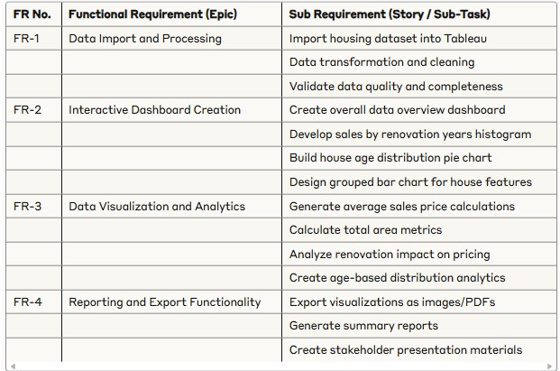

# Non-functionalRequirements:

Followingarethenon-functionalrequirementsoftheproposedsolution.

